ITEC 570 SPRING 2024

SQL Lab4B

Database Objects Ch 8
Ahmed Al touqi
For each document submitted on-line, please include your name, username, date, ITEC 570-001, reference lab number and title(if appropriate). You will turn in 4 screenshots.

Use the database tables in Figure P8.16 as the basis for Problems 16, 17, 18, 19, 20, 21, 22, 23, 24, 25, 26

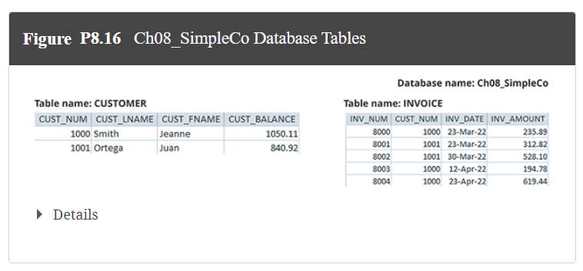

- Create the CUSTOMER table structure illustrated in Figure P8.16. The customer number should store integer values. The name attributes should support variable length character data up to 30 characters each. The customer balance should support up to six digits on the left of the decimal place and two digits to the right of the decimal place. Create a primary key on CUST_NUM.

- Create the INVOICE table structure illustrated in Figure P8.16. The invoice number should store integer values. The invoice date should store date values. The invoice amount should support up to 8 digits to the left of the decimal place and two digits to the right of the decimal place. Create a primary key on INV_NUM and foreign key on CUST_NUM.

- Write the set of SQL commands necessary to insert the data into the CUSTOMER table you created in Problem 16, as illustrated in Figure P8.16.

- Write the set of SQL commands necessary to insert the data into the INVOICE table you created in Problem 17, as illustrated in Figure P8.16.

Select ‘Screenshot 1’||user from dual;
Select * from CUSTOMER;
Select * from INVOICE;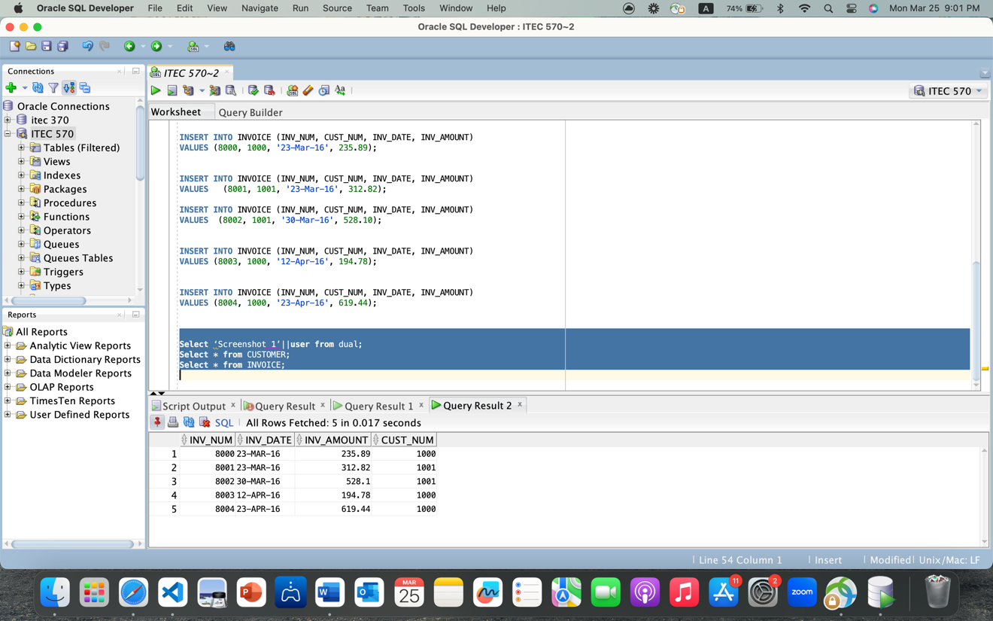

- Enable auto increment to generate values for customer numbers. The values should start with 2000. In Oracle, this is a sequence and set default value. Or trigger.

- Enable auto increment to generate values for invoice numbers. The values should start with the value 9000.

- Insert the following customer into the CUSTOMER table, using the auto increment from Problem 20 to generate the customer number automatically:

INSERT INTO CUSTOMER(cust_lname, cust_fname, cust_balance)
VALUES(‘Powers’, ‘Ruth’, 500)

Select ‘Screenshot 2’||user from dual;
SELECT * FROM CUSTOMER;
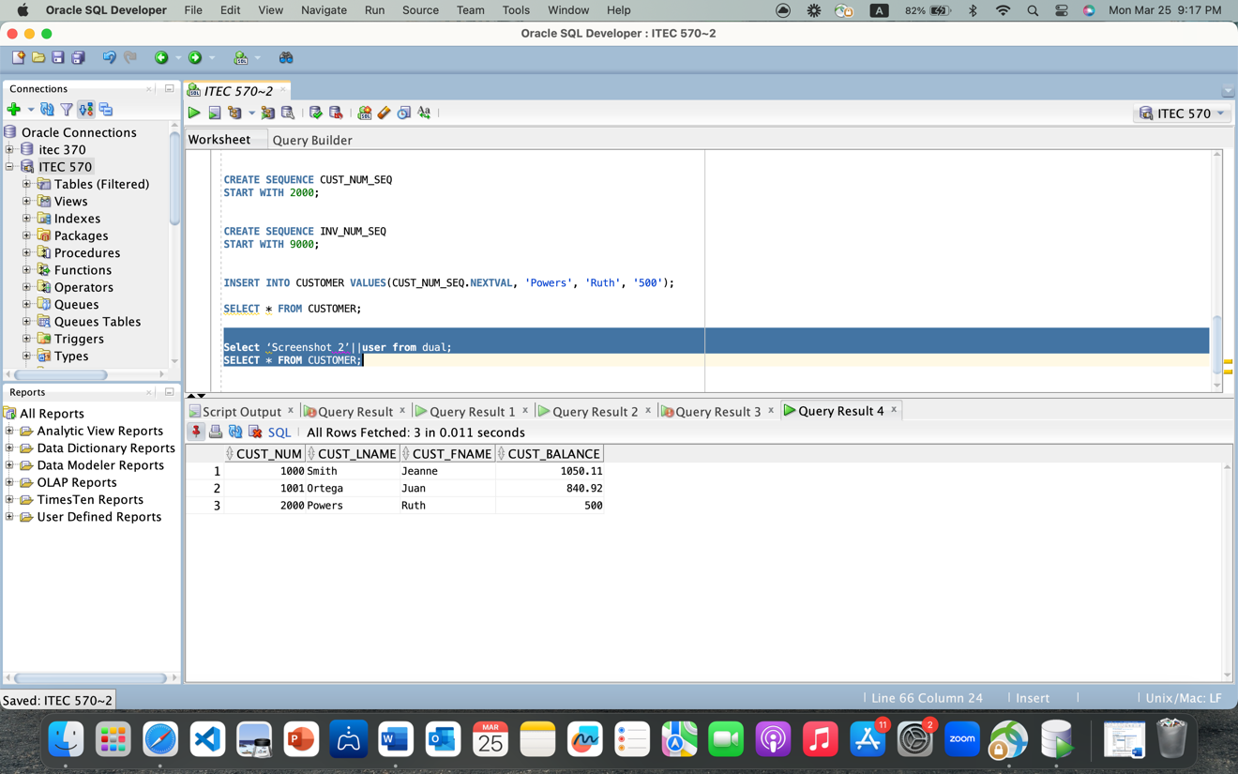
- Modify the CUSTOMER table to include the customer’s date of birth (CUST_DOB), which should store date data.

- Modify customer 1000 to indicate the date of birth as March 15, 1989.

- Modify customer 1001 to indicate the date of birth as December 22, 1988.

Select ‘Screenshot 3’||user from dual;
SELECT * FROM CUSTOMER;

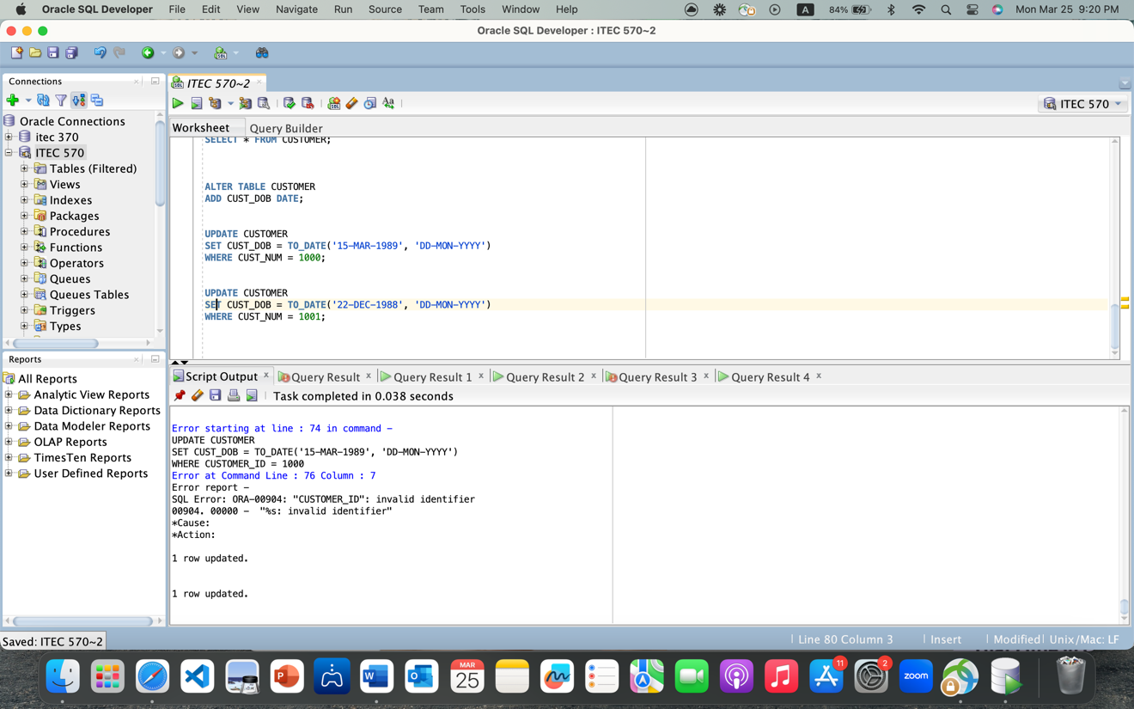
- Create a trigger named trg_updatecustbalance to update the CUST_BALANCE in the CUSTOMER table when a new invoice record is entered. (Assume that the sale is a credit sale.) Whatever value appears in the INV_AMOUNT column of the new invoice should be added to the customer’s balance. Test the trigger using the following new INVOICE record, which would add 225.40 to the balance of customer 1001. trg_updatecustbalance must be created first on CUSTOMER before running the insert statement below.

INSERT INTO INVOICE
VALUES(8005, 1001, '2022-04-27', 225.40);

Select ‘Screenshot 4’||user from dual;
Select * from CUSTOMER;
Select * from INVOICE;

